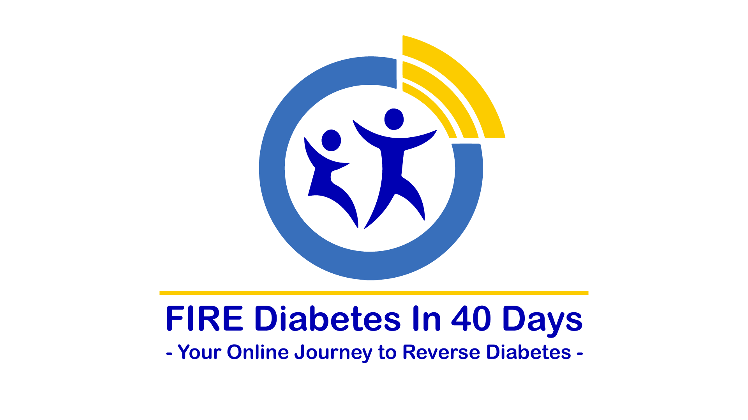
❶

Figuring Out Diabetes
- It's the insulin-resistance, stupid! -

What is insulin resistance?
To understand insulin resistance, you first have to understand insulin.
Insulin is a hormone produced by the pancreas in response to the presence of glucose in the blood.
Hormones are substances produced in one organ of the body, but which have their action in another, distant organ.
Insulin is a rather special hormone, since it has an effect on almost every cell of the body. It does not merely target one or two organs, but the whole body.
Insulin's main job in the body is to push glucose from the blood into the body's cells. It does not care what the cells do to the glucose, it just needs the glucose to be cleared from the blood. If the blood is clear of excess glucose, insulin's job is done.
Some body cells are more receptive to insulin's actions than other cells. Fat cells, for example, are always eager to respond to insulin. They turn glucose into fat and store it away quickly. Fat is a much more compact way of storing energy and takes up less space inside the cell. Fat is also inert, unlike glucose, which is reactive and likely to react with molecules inside the cell.
Liver cells also respond eagerly to insulin's actions. They store glucose in two forms: Glycogen and fat. Glycogen is quickly available if extra energy is needed. Fat takes a longer time to mobilise.
The more fat is stored inside liver cells, the less receptive those liver cells become to insulin's actions. They become sluggish to receive more glucose.
Muscle and brain cells are happy to receive glucose, but cannot accept much. Once they are full, they shut out any further requests by insulin. Muscle cells store glucose as glycogen.
Brain cells (neurons) burn glucose so rapidly, they don't have a mechanism to store it. Almost half of all the glucose consumed by the body in a day is used by the neurons. Neurons regulate the speed at which glucose enters them, to avoid excess glucose from damaging the nerves.
When the body's cells refuse to accept any more glucose under the pressure of insulin, the amount of glucose in the blood rises beyond its normal range. This is called pre-diabetes and is the first sign of insulin resistance developing.
Though fat cells remain happy to accept glucose and turn it into fat, there is a limited number of them. Some people seem to have an unlimited number of fat cells, but trust me, the fat cells are limited. Under the pressure of insulin, and in the presence of increasing insulin resistance, the fat cells grow larger and larger. This is the mechanism of obesity in Type 2 diabetes. Rising insulin levels drives obesity.
As the liver cells are pumped full of fat, a condition called Non-Alcoholic Fatty Liver Disease (NAFLD) arises. This is when the liver cells are too full of fat stores to do their normal duties properly. Also, the flow of blood through the liver has to squash through blood vessels narrowed by bulging fatty liver cells. This is the main cause of hypertension associated with Type 2 diabetes.
Eventually, the blood glucose levels rise even higher and the condition is then labelled as Type 2 diabetes or metabolic syndrome.
Over time, the cells lining the blood vessels are forced to accept glucose too, which they turn into fat. This further stiffens and narrows the arteries in the rest of the body, leading to an increased risk for heart attack or stroke.
"Insulin resistance" is the technical term for the body's refusal to act on the trigger of insulin.
Let us recap the typical elements of Type 2 diabetes in the correct order:
- High insulin levels
- Obesity
- Liver fat
- Hypertension
- High blood glucose
- Narrowing of arteries in heart and brain
Can you see that measuring blood glucose is not very helpful to assess the extent of the disease? Glucose levels are simply an end-stage symptom of something else that went wrong a long time ago. It may even be genetic.
In medical circles, it is well known that antibiotics create antibiotic resistance in bacteria. In the absence of antibiotics, bacteria do not develop antibiotic resistance. Likewise, insulin is the cause of insulin resistance. Full stop. Simple as that. Without elevated insulin levels, insulin resistance would not exist.
What went wrong in the first place is that the pancreas began producing more insulin than was good for the body. Only once the pancreas can be convinced to produce less insulin will the true cause of Type 2 diabetes be reversed.
Can you see that injecting insulin to treat Type 2 diabetes will make insulin resistance worse, not better? Adding insulin increases insulin resistance, just as adding antibiotics increases antibiotic resistance in bacteria.
Some people have genetically higher levels of insulin. In almost all these cases, these families have a history of severe famine in their genealogy. During a severe famine, only those able to turn almost any food into fat, survived. And those survivors passed on their special insulin-producing genes to the next generation. High insulin production is a survival mechanism that is selected during times of prolonged famine.
The problem is, none of us on this course are living in a severe famine situation, but our bodies are still adapted to famine conditions. The only way to "trick" the pancreas into producing less insulin is to reduce the trigger for insulin secretion, which is glucose in the diet.
The above picture of insulin resistance is over-simplified on purpose so that you can understand the basics of reversing insulin resistance. As we go deeper into the course, we will show you other ways in which insulin resistance develops, and how this should be addressed.

Reverse logic to reverse diabetes
Imagine it's Ash Wednesday morning after the Mardi Gras in Rio de Janeiro (or the morning after New Year's celebrations in Cape Town). You are part of the cleaning team that has to clear the streets of litter. You only have half an hour to complete your work before rush hour traffic hits.
First, you stuff the dirt bags full of litter. You quickly fill them up and as you wait for new bags to arrive, you look for open windows in the houses fronting the streets. You stuff garbage through them wherever you find them. It does not take long before the occupants notice what you're doing and slam the windows shut.
So, you begin knocking on doors. Every time a door is opened, you throw litter into the house. It does not take long before people stop opening their doors when you knock, or they only open the door on a tiny crack and you can't squeeze much junk in.
The garbage truck arrives with more bags and you begin filling them up again. Soon, these are filled and you're out of space again. This time round, you begin jumping on the garbage to compress it, so more can fit into the bags. The stuffed bags begin lining up the sidewalks and spilling over into the streets.
OK, so this story does not have a happy ending. In the end, there is too much garbage, the rush hour begins and cars crash into the stuffed bags lining the streets. It is a traffic jam that brings the entire city to a standstill.
Let me explain the parable. You are insulin. The litter is glucose. The streets are arteries. The city is your body. The houses are cells and organs.
You can see that more cleaning staff (= insulin) will not solve the massive litter problem. More litter bags (= fat cells) cannot solve the problem. Compressing the litter (turning glucose into fat) helps a little, but not for long.
Once the streets clog up with litter, you have a traffic jam (heart attack or stroke).
What is needed to clear the streets quickly is an incinerator to burn the litter on the spot. This is called "exercise".
More garbage removal trucks can also work to clear the streets. These are called microbes and they live in your gut, eating up excess glucose before it enters your body.
Of course, the best and easiest way to fight the litter problem is to prevent littering in the first place. This may require banning Mardi Gras celebrations, That would be highly unpopular, but very effective. Sometimes, you have to be cruel to be kind.
So, here is the reverse logic needed to reverse diabetes:
- You cannot reverse insulin resistance by adding more insulin to the body.
- You cannot lower blood glucose levels when glucose keeps entering your mouth.
- You cannot outrun a bad diet. No amount of exercise can compensate for a glucose-rich diet.
- You cannot store all the excess glucose. Some / Most of it has to be burnt.
- You cannot stabilise blood glucose without the correct gut flora.
- You cannot lose weight if insulin levels remain high.
- You cannot reverse hypertension if the liver is full of fat.
Let's turn the logic the other way. In order to reverse Type 2 diabetes, I must:
- Restrict glucose in my diet to near-zero levels
- Lower insulin levels
- Clear my liver of fat.
- Increase my metabolic rate
- Restore my gut flora
And that is exactly what FIRE Diabetes in 40 Days will teach you.

